To highlight the current active route

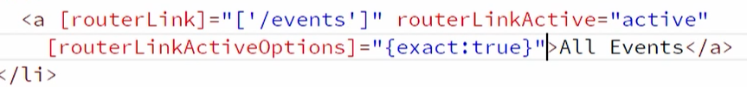

Preloading data for components

